Symposium Abstracts
Future Visualities
Visual Methods & Ethnography (VM&E)
June 1st, 2022
Edinburgh Napier University Craiglockhart Campus, 219 Colinton Road, Edinburgh, EH14 1DJ

Contents
Keynote Abstracts 6
Dr Fatema Kawaf 6
Screencast Videography: Toward a Visual, Dynamic Understanding of the Digital Realm 6
Dr Brett Lashua 7
Visualising popular music heritage: (Re)mapping the beat? 7
Dr Terence Heng 8
Blending the Senses: Photography, Poetry and (Auto)Ethnography 8
Stream 1 Work and Leisure 10.15-11.30am room 2/06 9
Beyond data: the art of portraiture as tool for ethnographic observation, analysis and representation (Rommy Anabalon Schaaf, University College London) 9
Exploring Transformative Servicescapes through Risographs, Illustrations and Graphic Recordings (Kathy Hamilton, Holly Porteous, Juliette Wilson, University of Strathclyde) 10
Photo-narrative Frames of Career Trajectories: “Picturing” the professional lives of expat English teachers (Vincent Greenier, University of Aberdeen) 14
Stream 2 10.15-11.30am Touristic Landscapes (room 2/09) 15
Food Activism and Sustainability: A Virtual Ethnography Of 'Realfooding' Phenomenon on Instagram (Orea-Giner, Alicia EIREST, Université Paris) 15
Arts-based research and the intersected tourist gaze (Louise Todd, Edinburgh Napier University) 17
New communication spaces of collective identity: reinventing the urban landscape through visual representations of the past (Anabela V. Simões, University of Aveiro, Portugal) 19
Stream 1 Education 12.30pm-1.15pm room 2/06 21
The use of Volunteer Employed Photography within undergraduate assessment: An international field trip perspective (Sarah Snell, Edinburgh Napier University) 21
Language as a boundary and a catalyst: an interdisciplinary approach to the language of school exclusion (Kathryn Westwood, Manchester Metropolitan University) 22
Stream 2 Semiotic Landscapes 12.30-1.15pm room 2/09 25
The Cultural revolution 2.0 in China: the birth of new Rightists/dissents (Yaodi Wang, University of Southampton) 25
50+ Fashion Influencers: Cognitive age and aesthetic digital labours (Ashleigh Logan-McFarlane, Edinburgh Napier University) 28
Stream 1 Theatre and Stories 2-3.15pm room 2/06 29
Thinking with my hands. Knitting as a way of analysing and connecting autoethnographic and ethnographic stories (Dr Javiera Sandoval Limarí, Institute of Education – UCL) 29
The Soteriological Drama of Justice: Buddhist Iconography, Judgement, and the Visual Theatre of Courts in Bhutan (Professor Richard W Whitecross, Edinburgh Napier University) 30
What’s in a Cake: Community, Diversity and Inclusivity (Dawn Smith & Mabel Victoria, Edinburgh Napier University) 31
Stream 2 Identity and work 2-3.15pm 2/09 32
Assessing the visual: participant generated photographs of family dinner (Professor David Marshall, Edinburgh University) 32
Online Fashion and Performative Cyber-Power of Social media Influencers (Fatma Bouarour, University of the West of Scotland) 33
An exploratory study of how female entrepreneurs make sense of being a mother and business owner during an unexpected event: The case of the Covid-19 Pandemic (Professor Anna Watson, Dr Nika Balomenou, Dr Hannah Noke, Professor Brian Garrod) 34
Poster Presentations 36
Labored Work of LGBTQ+ Influencers on Pride Branding (Raian Burgos Razal, Aarhuss University) 36
Botched decisions? How Instagram influences the cosmetic surgery and non-surgical procedures consumption decisions of young women (Jasmiina Milne, Edinburgh Napier University) 37
How do Saudi PhD(s) in the UK use Twitter? (Badryah Almesfer, Newcastle University) 38
The “cultural probe” and the art school, by Dan Bernstein, University of the Arts London 40
How do Chinese gamers identify with each other in the game League of Legends?: An ethnographic study (Dan ZHAO University of Bath) 42
Picturing Java (Wo)man: Visual Reconstruction of Colonial Palaeoanthropology (Fiona Asokacitta University of Oxford,) 44
Thinking with my hands. Knitting as a way of analysing and connecting autoethnographic and ethnographic stories (Dr Javiera Sandoval Limarí UCL) 45

Keynote Abstracts

Dr Fatema Kawaf

Screencast Videography: Toward a Visual, Dynamic Understanding of the Digital Realm

In today’s fast-paced, data-rich, dynamic, social, and visual world, many of our experiences, activities and daily interactions have shifted to the digital realm – accelerated by the covid19 pandemic. Socializing, dating, gambling, shopping, consumption, and searching for information, ideas, and solutions are just some of the many things we do online. And with the advances in AR and VR technologies, our current digital lives are about to be transformed within the newly established metaverse – a socially and technologically engineered space. Crossing into this digital realm necessitates a new way of thinking and adopting an innovative approach to studying digital experiences, digital selves, and digital life. I present Screencast Videography (SCV) as a novel research method that enables the videographic research of digital interactions and experiences. Using videos of screen activities and outputs (screencasts) for data collection, SCV captures digitally-occurring experiences and interactions in visual and dynamic forms. The method offers unique insights beyond the already established in-depth qualitative and often visual methodologies such as Netnography and Digital Ethnography. Indeed, the accessibility of content, especially visual content, on social media has been low hanging fruit for researchers in this field. However, whilst these methods have had burgeoning success, they focus mainly on the digital footprint – the trace users leave behind in the form of posts, comments, reactions, etc. SCV came to light to bridge the epistemological gap in understanding digital experiences and interactions as it moves beyond the digital footprint and captures the true visual and dynamic nature of digital experience.

Dr Brett Lashua

Visualising popular music heritage: (Re)mapping the beat?

In this talk I focus on visual representations of popular music heritage in cities. Guided by the notion that ‘every place deserves an atlas’ (Solnit 2010: vii), I aim to locate and critically question popular music heritage through a series of mappings – some ethnographic, others archival, and some pedestrian or psychogeographic – in Liverpool (UK), Leeds (UK), and Cleveland (USA). Mappings can help to open up generative processes of constructing, conducting and questioning research and knowledge production. For Moretti (1998: 3-4), maps are not an ending but the start of discussions: ‘a good map is worth a thousand words, cartographers say, and they are right […] it raises doubts, ideas. It poses new questions, and forces you to look for new answers’. In my research, mappings have helped to draw attention to edges, borders, and margins. If Liverpool, Cleveland and Leeds are peripheral or ‘edge’ cities (Higginson and Wailey 2006) their popular music heritages are – varyingly – on edges (and ‘edgy’) too. Yet, as Moretti (1998: 3) also put it, such mappings help to bring ‘to light relations that would otherwise remain hidden’ between music, people, heritage and cities. Mapping also can be useful in cities described as having a ‘lost’ popular music heritage (Carr 2019), hidden even to many who reside there. That is, mapping popular music heritage can help to produce an atlas that these cities deserve.

Dr Terence Heng

Blending the Senses: Photography, Poetry and (Auto)Ethnography

Visual methods are often seen as a “creative edge” that complements other “traditional” research methods like ethnography, interviews and participatory approaches. In particular, photographs are used in a variety of ways – as illustrations, as elicitation material, as objects of study, and most importantly as visualisations that create ethnographic layers of meaning. However, it has only been in the last 7 years or so, where digital photography has become ubiquitous, that visual methods are starting to be taken seriously by a wider audience of users.
In this presentation, I will be discussing the various ways that documentary and/or creative genres of photography can inform, enhance and disrupt text-based ethnographic approaches in the social sciences. Drawing from two recently published monographs – Of Gods, Gifts and Ghosts: Spiritual Places in Urban Places and Diasporas, Weddings and the Trajectories of Ethnicity, I will examine how my photographic and creative practices have evolved to visualise and verbalise my fields of research. I will explore how photography, combined with creative writing like poetry and narrative prose, is a powerful method to map and communicate the spatiality, emotions and materiality of various social themes, namely diaspora, identity and death

Stream 1 Work and Leisure 10.15-11.30am room 2/06

Beyond data: the art of portraiture as tool for ethnographic observation, analysis and representation (Rommy Anabalon Schaaf, University College London)

This contribution explores the possibilities of drawing portraits as a complementary tool for observation, as a method of analysis and as a form of representation in ethnography.

I started drawing in 2019 when I returned to London after my fieldwork in Chile. It was a way for me to deal with my mental issues and also as an alternative way to work with my participants during the pandemic. Since then, I have developed a technique to incorporate drawings, specifically portraits, in my research process.

I usually start a portrait by drawing a silhouette of a face to then, focus on the details of the eyes. This is when I start thinking about the people I interact with. Eyes always make me think about their life stories and trajectories. Then, once I’m happy with the eyes and I’m able to see the person I’m drawing, I continue with the nose. This takes me to people’s personalities, the way they behave, the way they act. Sometimes it comes easy and it takes me a short time, some other times I have to start over and over again. The next part is the mouth. When I draw lips I think about people’s emotions and feelings. Ears tell me how people hide certain things from what is commonly visible. Finally, when I draw their hair, I reflect on the way people present themselves to others, the image they project to society.

Through these drawings I observe, collect and analyse data from my participants in a way that complement traditional approaches. These portraits also illuminate my writing as, once they are finished, I have a great deal of data which I can translate into words. As representation, portraits remind me that we work with people, not data.

Exploring Transformative Servicescapes through Risographs, Illustrations and Graphic Recordings (Kathy Hamilton, Holly Porteous, Juliette Wilson, University of Strathclyde)

This abstract explores our approach to embedding visual methods in our Transformative Service Research (TSR) project. Our project seeks to conceptualise a transformative servicescape by exploring the emplaced nature of transformative service delivery and how well-being is enacted through the construction of the physical space. It is based on a case-study of Glasgow Women’s Library (GWL) which is a feminist space that hosts a wide range of public events and includes exhibition spaces, a library, archive and museum. Given that creativity is embedded within the culture of GWL, we wanted to reflect this in our methods and actioned three approaches that resulted in visuals from both amateur and professional artists.

First, our data collection encompassed two creative risograph printing workshops where participants were encouraged to explore and share what difference GWL had made to their lives. With facilitation from an experienced artist, participants were guided through the process of creating a postcard-sized print to express personal experiences of transformation in colour, shapes and writing. Second, we commissioned a series of illustrations from a professional illustrator that were inspired solely by extracts from interviews with staff, volunteers, users and networks of GWL. Third, we commissioned graphic recordings / visual minutes for a research dissemination event.

These approaches have encouraged reflections about how arts-based research informed and complemented our more conventional approaches to data collection. They have also been crucial in supporting dissemination of the research to the general public through an exhibition.

(See below for related images)

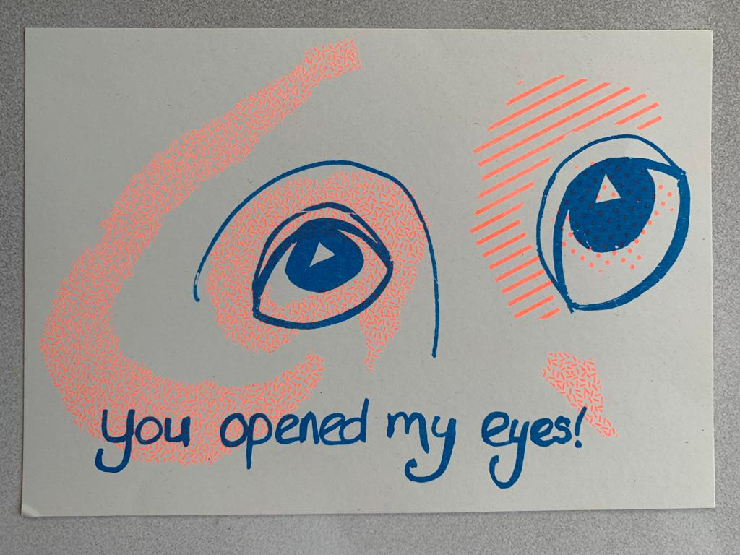

Example of Risograph Print from Arts-based Research
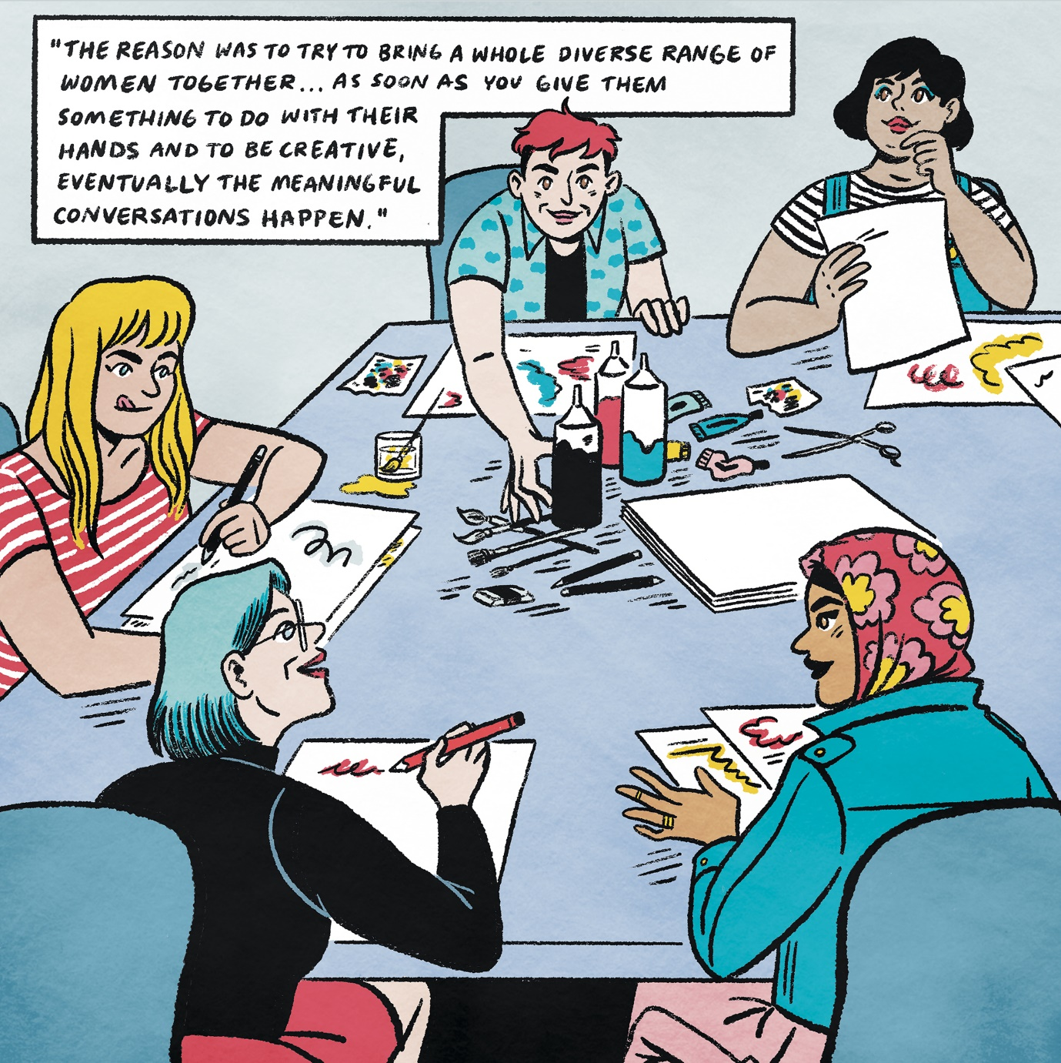

Example of Illustration from interview data
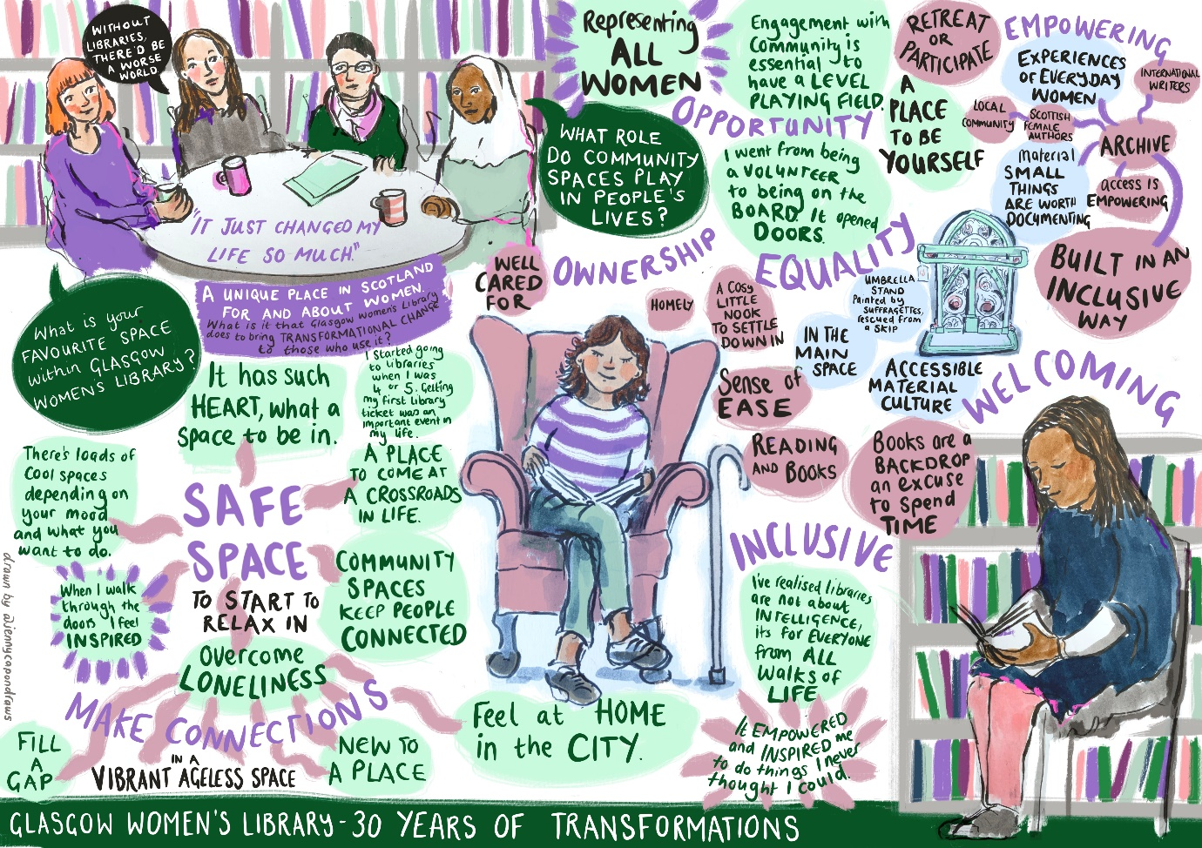

Example of Graphic recording/Visual Minutes

Photo-narrative Frames of Career Trajectories: “Picturing” the professional lives of expat English teachers (Vincent Greenier, University of Aberdeen)

At the root of narrative research is the contention that it empowers the voice of the participant and invokes an empathic responsibility within the researcher when communicating the stories of those they research. With this intention, this study used a narrative inquiry approach to explore the professional identities of expatriate English teachers living and working in South Korea. In this study, we introduce photo-narrative frames (PNFs) which use participant produced photographs as a visual stimulus for important events in their career along with statement prompts that initiate reflections of the participants’ feelings and thoughts. PNFs extend traditional methods of narrative research by incorporating visual data that proposes to connect the participants’ recollection of events and experiences to photographs that represent pivotal moments in their teaching career. By including a photograph in the narrative frame, we seek to evoke responses that help participants explore new directions and understandings of their experiences and access sensory responses to the moments they capture. The focus of this talk is on the methodological processes of integrating narrative frames with participants’ photographs to generate concise, embodied memoirs of significant moments in expatriate language teachers’ careers. The talk will provide examples of how photographs grant a visual layer that can empower participants to share their experiences and personal histories and discuss the instrument design, analytical processes, and ethical considerations when developing and employing PNFs in applied linguistics and other social science research.

Stream 2 10.15-11.30am Touristic Landscapes (room 2/09)

Food Activism and Sustainability: A Virtual Ethnography Of 'Realfooding' Phenomenon on Instagram (Orea-Giner, Alicia EIREST, Université Paris)

ABSTRACT

Customers' lifestyle has a direct effect on their leisure choices (DaSilva et al., 2020). Consumers' purchase decisions related to tourism and leisure services are affected by wellness and healthy lifestyles (Damijanić, 2019). Besides, lifestyle movements are focused on lifestyle choices to promote social change from one's identity (Haenfler et al., 2012). Lifestyle movements encourage social movements associated with social change. 'Food activists', through the analysis of their dishes, denounce injustices about the food system while promoting changes in eating habits to push for a change in consumption in favour of their notion of 'good food' (Alkon and Guthman, 2017). Schneider et al. (2017) identified different types of forms of food activism using different media since it can be done through web pages, blogs, social networks, or mobile applications.

Food activism is increasingly being assisted by online and social media, which provide users with various affordances that aid activism in various ways and lead to specific activist actions. Certain lifestyles fads are linked to sustainability, such as vegetarianism, minimalism, and zero waste. One of the most influenced generations by food lifestyle movements is Generation Z. Gen Z consumers follow healthy eating habits, and their discussion as customers are linked with sustainability activism.

This article aims to analyse the influence on the lifestyle and sustainable choices of Gen Z through the participation in a virtual community in Instagram and TikTok, named 'Realfooding'. This research is based on participant observation through virtual ethnography and online interviews. The 'Realfooding' movement is linked to a more sustainable life and consider the scientific literature to make better choices as consumers. This lifestyle movement provokes a new form of travelling and induces more responsible and sustainable choices, especially for Gen Z consumers.

Keywords: Food activism, lifestyle movements, consumption activism, Generation Z, traveller behaviour

REFERENCES

Alkon, A. H., & Guthman, J. (2017). 13. Conclusion: A New Food Politics. In The New Food Activism (pp. 316-324). University of California Press.
Damijanić, A. T. (2019). Wellness and healthy lifestyle in tourism settings. Tourism Review.
DaSilva, G., Hecquet, J., & King, K. (2020). Exploring veganism through serious leisure and liquid modernity. Annals of Leisure Research, 23(5), 627-644.
Haenfler, R., Johnson, B., & Jones, E. (2012). Lifestyle movements: Exploring the intersection of lifestyle and social movements. Social Movement Studies, 11(1), 1-20.
http://uk.businessinsider.com/millennials-vs-gen-z-2016-2

Arts-based research and the intersected tourist gaze (Louise Todd, Edinburgh Napier University)

There is an extant of research devoted to the ocular nature of tourism as a set of visual practices, and accordingly, to the tourist gaze thesis (Urry & Larsen, 2011). Within this construct, it is suggested that tourists’ and others’ visual practices and performances, such as photography and sightseeing, form an intersection of gazes (Crang, 1997; Lutz & Collins, 1991). At present, much consideration of the tourist gaze is captured and framed, through photographic practices: particularly those undertaken by tourists, and within tourism settings (Ekici Cilkin & Cizel, 2021). Although the tourist gaze is of interest on interdisciplinary bases, there has been little attention directed to this construct through arts-based research. As a transdisciplinary approach which combines tenets of creative arts in research contexts, arts-based research uses the artistic process as a way of understanding (Leavy 2020; McNiff, 2008).
My presentation will extend the existing photographically framed understanding of the tourist gaze through arts-based research. Firstly, I will reflect on my reflexive ‘others’: as an artist, researcher, and viewer. I will then discuss my arts-based approach to understanding the tourist gaze, with tourists and tourism subject to my intersected gaze. My arts-based method involves visual art practices of drawing and painting, both within embodied tourism contexts, and through using tourists’ photography as source materials. The presentation will therefore present my recent research which studies the tourist gaze; and my artwork will also be considered through the intersection of my own others’ gazes, of artist, researcher, and viewer.

References
Crang, M. (1997). Picturing practices: research through the tourist gaze. Progress in Human Geography, 21(3), 359-373.
Ekici Cilkin, R., & Cizel, B. (2021). Tourist gazes through photographs. Journal of Vacation Marketing, 13567667211038955.
Leavy, P. (2020). Method meets art: Arts-based research practice. Guilford Publications.
Lutz, C., & Collins, J. (1991). The photograph as an intersection of gazes: The example of National Geographic. Visual Anthropology Review, 7(1), 134-149.
McNiff, S. (2008). Art-based research. In: J. G., Knowles, & A. L. Cole, (2008). Handbook of the arts in qualitative research: Perspectives, methodologies, examples, and issues. pp. 29-40. Sage.
Urry, J., & Larsen, J. (2011). The tourist gaze 3.0. Sage.
Arts-based research and the intersected tourist gaze (visual materials)

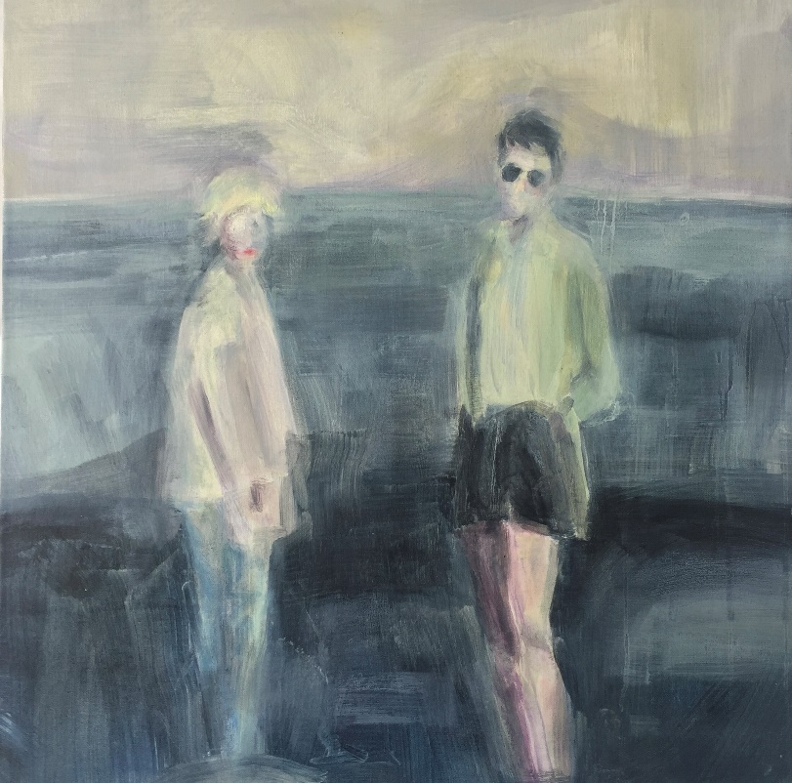

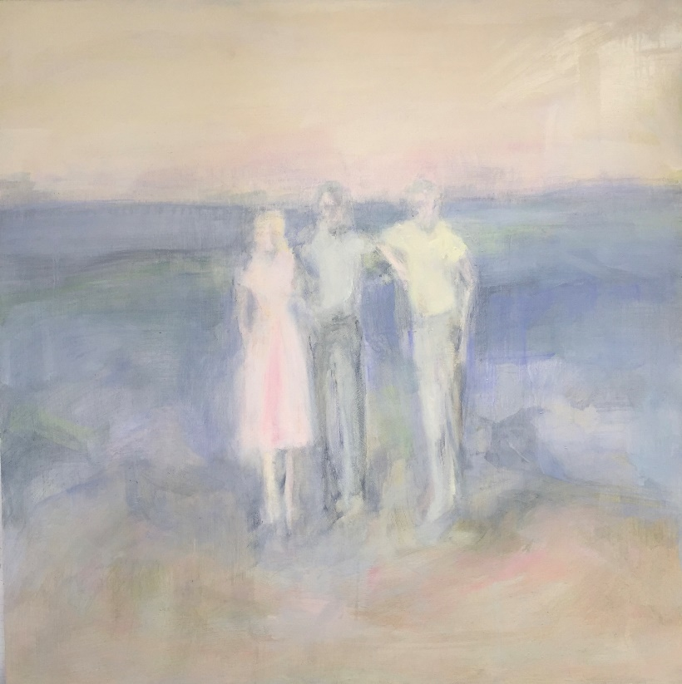
Upper image: ‘Sunglasses for reflection’, 50cm x 50cm, oil on cradled wooden panel
Lower image: ‘Memory Travel’, 50cm x 50cm, oil on cradled wooden panel
Both images © Louise Todd (Artist and Researcher)

New communication spaces of collective identity: reinventing the urban landscape through visual representations of the past (Anabela V. Simões, University of Aveiro, Portugal)

Cultural tourism is one of the largest and fastest-growing global tourism markets and, in the city of Aveiro, it is one of the segments that has expanded more noticeably. Because their interplay creates distinctiveness, culture and tourism have developed a mutually beneficial relationship that strengthens the attractiveness and competitiveness of the region and, simultaneously, enhances culture by generating resources to support cultural heritage and cultural offer.
Dominated by a vast lagoon estuary, Aveiro has historically been associated with sea trade, fishing and salt production. Symbolic elements of an either experienced or received past are present everywhere, from the traditional cobblestone pavements with nautical elements to the many wall panels depicting fishing scenes. Crossed by a network of canals, Aveiro is also known for its colourful vessels with drawings of historical facts, national heroes or popular devotion. Alongside these more traditional representations of cultural memory and identity, a new trend has emerged: by combining street art and graffiti, the region has been transforming itself into an open-air art gallery where many of these symbols are also popularly celebrated and integrated into the official touristic routes.
Drawing on Jan Assmann’s Cultural Memory theory, my presentation aims to offer a reflection upon street art not only as a touristic attraction or instrument of urban regeneration but, especially, as a phenomenon that contributes to one’s cultural identity construction. I will argue that it can be understood as a form of ‘communicative memory’, an ephemeral vehicle into our history, knowledge, traditions and practices, one that, by telling the story of who we are, stimulates awareness of selfhood and a feeling of belonging to a place and a community.

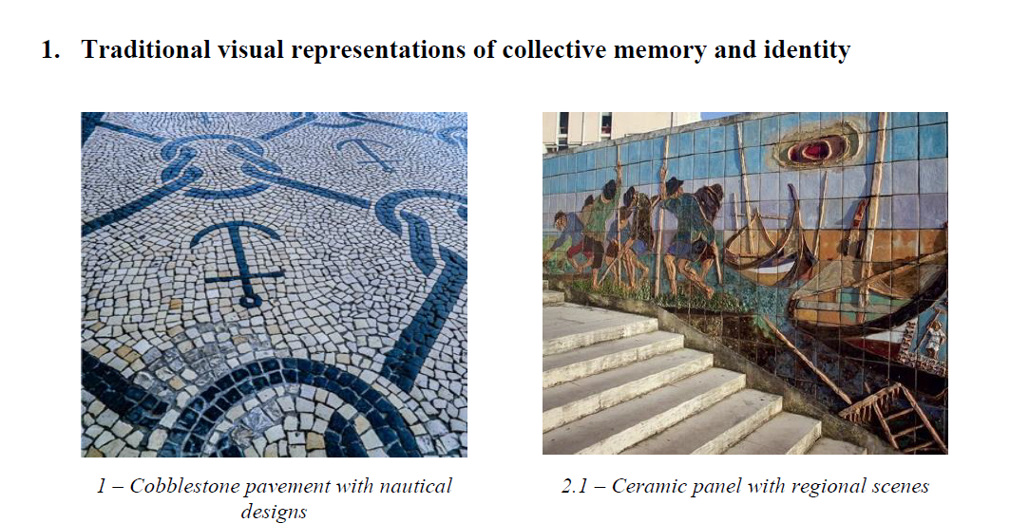

Stream 1 Education 12.30pm-1.15pm room 2/06

The use of Volunteer Employed Photography within undergraduate assessment: An international field trip perspective (Sarah Snell, Edinburgh Napier University)

Volunteer Employed Photography (VEP) has been used within tourism studies to better understand destinations and the way residents and visitors interpret and experience them. Seen as an innovative research method, VEP encourages participants to engage with the destination through self-selected photographs and reflection. Known for its ability to enhance observational skills, VEP has the potential to be used as a method of assessment, enhancing the academic curriculum, and developing students’ understanding of subject related phenomena.
Drawing on participant observation, a post visit focus group, and analysis of students’ work, this study investigates the benefits associated with, and the utility of, VEP as an assessment tool for undergraduate students on an international field trip. The method allowed students to research tourism and event phenomena through the use of VEP with a tourism lens, and a subsequent narrative analysis.
While abroad students took photographs which link to their experiences, and their understanding of subject specific academic discussions such as: tourism impacts, destination image, and visitor attraction management. Upon their return, they worked to select, analyse, and reflect, on images which illustrated their experiences and the academic concepts they had observed for their submissions.
At first, some students were apprehensive about the task and this necessitated additional guidance and reassurance, however, with support, they embraced and enjoyed the alternative method of assessment. Whilst their approached was not always strictly VEP, the use of photography aided in their understanding, and subsequent interpretation, of the destination and observed phenomenon related to their field.
The research demonstrates how VEP as an assessment method benefited the students through enhanced observational skills, an deeper understanding of their subject, and an exposure to innovative research methods. The technique further enabled students to meet the learning outcomes of the module and assisted in providing an enhanced student experience.

Language as a boundary and a catalyst: an interdisciplinary approach to the language of school exclusion (Kathryn Westwood, Manchester Metropolitan University)

This paper outlines the discourses prevalent in school exclusion and their effect upon those involved. It discusses the potential of a Participatory Research (PR)-informed, Critical Discourse Studies (CDS) approach for addressing the unequal distribution of power evident in the context.

Rates of exclusion have been rising year on year since 2013, with the highest numbers being from mainstream secondary schools (DfE & National Statistics, 2019). The most common reason schools give for exclusion (following frameworks provided by DfE) is ‘persistent disruptive behaviour’. Therefore, in order to understand why exclusion is happening, there needs to be a clear understanding of what is being disrupted and how. Taking a CDS approach, this paper argues that it is a range of established, overlapping, powerful discourses in schools that are being disrupted - specifically, by the language and behaviour of young people at risk of exclusion. After clarifying what these discourses are, I explain how they work to create boundaries on the behaviour, emotions, and realities of young people and school staff. Subsequently, this paper outlines how taking a CDS approach to the language of exclusion is apt for addressing these boundaries.

Finally, participatory, arts-based approaches are discussed in their potential to inform how excluded young people’s language can be seen to reimagine new realities and catalyse change (Finely, 2005). Thus, this paper explores how an approach informed by CDS and PR can begin to address unequal power distribution in school exclusion - by seeing the potential of language to be both a boundary and a catalyst.

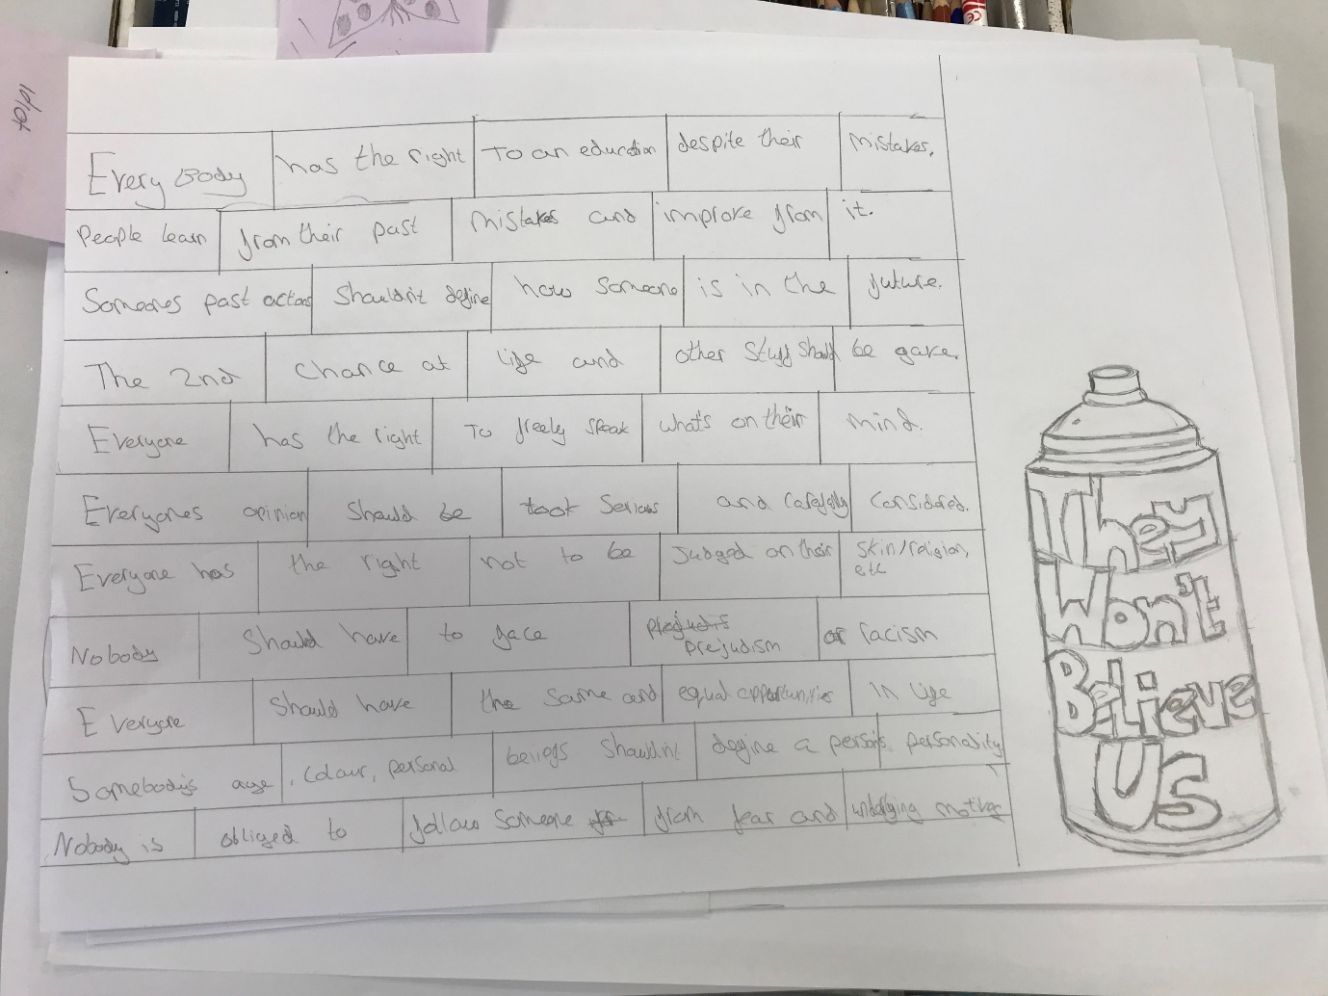
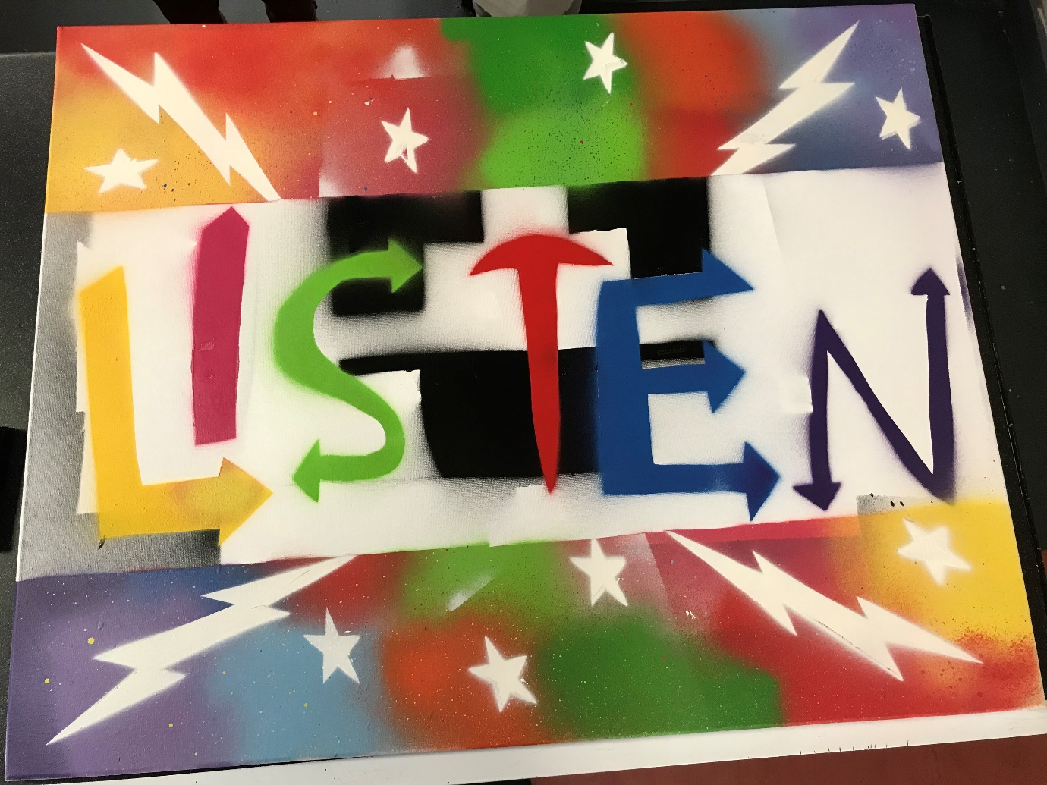
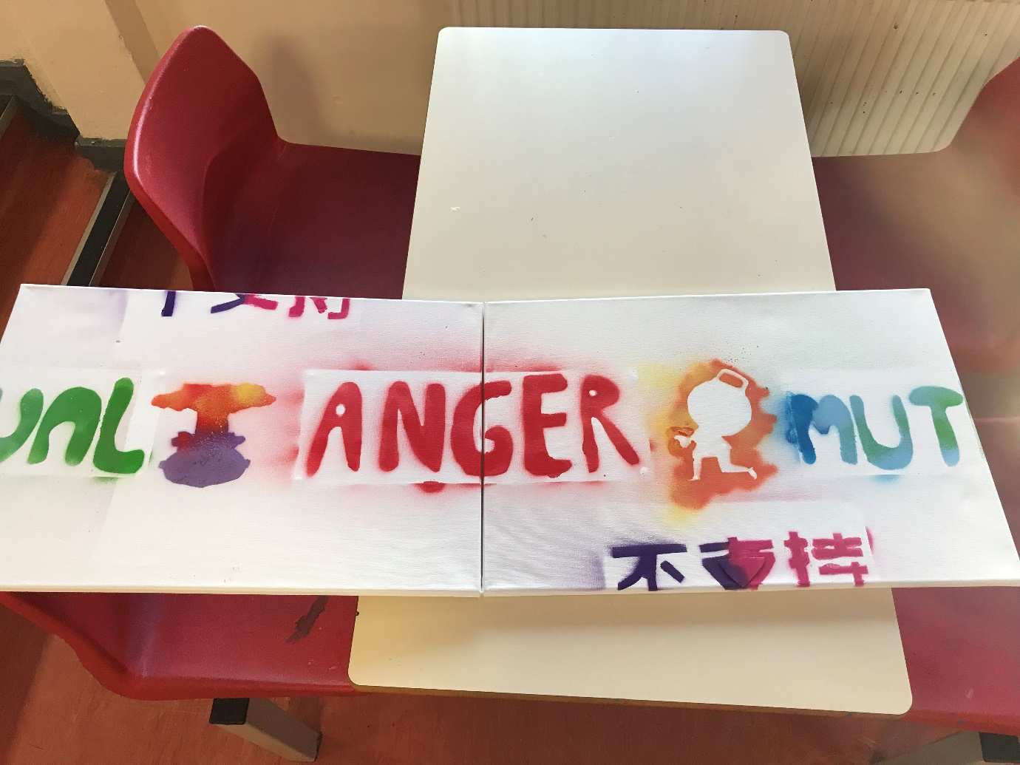

Stream 2 Semiotic Landscapes 12.30-1.15pm room 2/09

The Cultural revolution 2.0 in China: the birth of new Rightists/dissents (Yaodi Wang, University of Southampton)

China, known for its speech control and one-party politics, has taken control of online speech with greater focus and resources in the post-epidemic era. There is widespread awareness of the Cultural Revolution in history, but due to the failure of political system reformation, another cultural revolution, ‘Cultural Revolution 2.0’, is being theorised to account for current opposing political forces, and how they operate in the current in landscapes characterised by censorship, ideational control, and political positions.

Unlike Cultural Revolution 1.0, Cultural Revolution 2.0 is online and offline. The online manifested itself in various forms of speech control. In order to prevent meanings being detected, the original Chinese characters have been replaced by a large number of pinyin (Latinized Chinese writing), English or other foreign languages, emojis, etc., on online platforms. Moreover, rightists (dissidents sharing pollical views in online domains) create wider discourses understood by the intended audience, avoiding heavily censored software. The offline part is a symbolic war where linguistic landscape relate to the cultural revolution can be noted both from top-down and bottom-up.

This study intends to provide an accurate description of the current state of online speech control in China and the civilian political struggles that it provokes. It discusses the occurrence of Cultural Revolution 2.0 in terms of official online and offline language use. This research will be approached as an ethnographic study because this approach enables researcher to understand, investigate and analyze the meanings of Rightists' online linguistic, discursive and cultural practices in a very detailed manner in the context of real set online/offline world.

For the offline part, I aim to show both the historical and present linguistic landscape in China to indicate the emergence of the cultural revolution 2.0 and the current state of the Chinese sociopolitical problems. The offline part focuses on the discourses produced by Rightists/dissents through memes, emojis, and multimodal resources given by online affordances.

By adopting the discursive analysis of both the official and the Rightists’ online offline practices, the results highlight that first the offline data shows the discursive and multimodal similarities between two cultural revolutions. Second, the speech censorship is China now is more than prohibited words but the definition of ‘speakable’ domain under the Cultural Revolution2.0. Last, the political dissents do exist online and offline and they are able to utilize communicative recourse to show their political identity.
Some sample pictures and memes are listed down below:
- Offline:
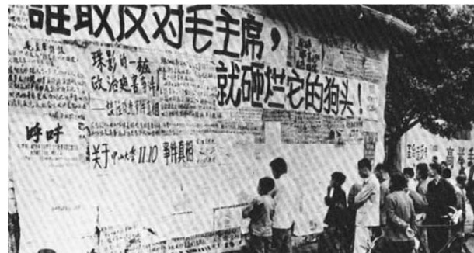
Figure 1.1 Smash the head of anyone who opposes Chairman Mao
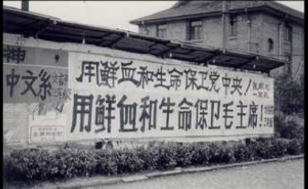
Figure 1.2 Defending the Party Central Committee with blood and life, protecting Chairman Mao with blood and life

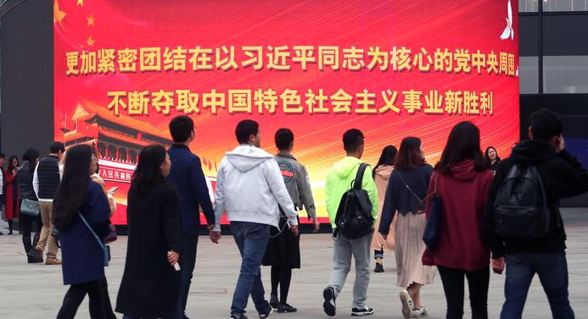

Figure 1.3 Unite more closely around the Party Central Committee with Comrade Xi Jinping at its core. Continuing to win new victories in the cause of socialism with Chinese characteristics.

50+ Fashion Influencers: Cognitive age and aesthetic digital labours (Ashleigh Logan-McFarlane, Edinburgh Napier University)

This work demonstrates how #50+ fashion Instagram influencers contribute to the social construction of cognitive age through their aesthetic digital labours. This work employed a non-participative netnographic approach (Kozinets, 2015) in the form of a visual and textual analysis of over 300 Instagram posts including the image itself, captions, and comments. We identified 32 50+ micro, meso and macro fashion influencers from across the globe with a following ranging from 7, 000 to 3.8 million). We borrowed elements of Schroeder’s (2006) critical visual analysis for coding and interpreting our images. Specifically, description (image, physical appearance, and context), subject matter (people, objects, places, events), form (style), medium (digital), style (fashion movements), genre and comparison (to fashion influencers). We take the position that images are embedded in cultural practices rather than concentrating on mediums and their differences.
This presentation will focus on the visual analysis of Instagram images. Specifically, we will look at the labours involved in outfit selection, background choices, bodily poses, post construction, hashtag and emoji use and how this is used to convey expressions of look age among 50+ fashion influencers.
Kozinets R. V. (2015). Netnography Redefined 2nd ed. London: Sage.
Schroeder, J. E. (2006). “Critical Visual Analysis.” In Handbook of Qualitative Research Methods in Marketing, edited by Russell W. Belk, 303–321. Cheltenham: Edward Elgar.
https://www.instagram.com/p/Bv_2xHWBd5b/ https://www.instagram.com/p/Byf1DrElhoh/

Stream 1 Theatre and Stories 2-3.15pm room 2/06

Thinking with my hands. Knitting as a way of analysing and connecting autoethnographic and ethnographic stories (Dr Javiera Sandoval Limarí, Institute of Education – UCL)

This presentation will explore the use of knitting, as art making, to analyse and to connect stories of my ethnographic fieldwork with autoethnographic data, to create new meaning for both. The Blanket is a crochet piece that I started to make after my mother’s death during my PhD. While knitting, I managed to understand and to connect my grieving self to the research I was doing, as the arts practice evokes emotions and foster reflection (Leavy, 2015). During the presentation I will explore on how knitting and weaving in crochet squares lead me to new understandings of the fieldwork I’ve done with Haitian children in a Chilean school. These new understandings, I propose, were a way of thinking with the hands, creating new connections, which were not visible to me while I was engaging in more traditional forms of data analysis. Within these connections, loss appears as a concept that created the interweaving between all the pieces. Myself in grief, the passing of my mother who lost her language due to Alzheimer’s disease and the loss of the mother tongue of Haitian children in Chilean schools. Engaging in arts, through the creation of The Blanket, was the media to reach the analytical categories that I am using to understand the experience of children in their process of losing their mother tongue and to find ways of resisting the loss of the mother tongue and the loss of the tongue of the mother.
Leavy, P. (2015). Method Meets Art. Art-Based Research Practice (Second Edi). The Guilford Press.
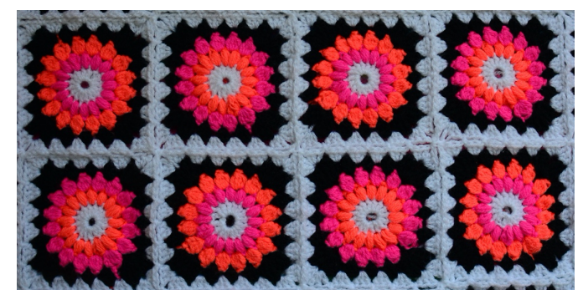

The Soteriological Drama of Justice: Buddhist Iconography, Judgement, and the Visual Theatre of Courts in Bhutan (Professor Richard W Whitecross, Edinburgh Napier University)

On June 16th, 2014, a ceremony was held to inaugurate the new Supreme Court complex in Thimphu. The Supreme Court complex represents the most recent expression, if not the culmination, of a process of court design and judicial architecture in Bhutan. The evolution of the design and construction of Bhutanese courthouses is an important, if overlooked, feature of the modernisation of the Bhutanese legal system. Courthouses and courtroom are familiar to us through film, television, newspaper and online coverage of major court cases and criminal trials. Yet, academic interest in the architecture of courthouses and the design of courtrooms is relatively recent (Mulcahy and Rowden, 2020). To understanding of how the law operates it is important to consider the settings in which it is manifested: the courthouses and courtrooms.
Commenting on the significance of courthouses in the US, Chief Justice Hennessey states that “our courthouses are monument to our legal tradition, its noble purpose and occasional tragic miscarriages. They evoke the memory of historical events and of the aspirations, frustrations and fears of many people…they are not merely buildings, rooms and furniture but are, rather, monuments that evoke several centuries of human effort and progress”. Based upon a legal anthropological approach, this presentation considers the idea of “legal” tradition and its ideals, of the range of responses to courts by the general population and finally as expressions not only of tradition but also of progress, of modernisation and, as it will be argued, in the Bhutanese context to democratisation.

Mulcahy, L and Rowden, E (2020) The Democratic Courthouse: A modern history of design, due process, and dignity. London: Routledge

What’s in a Cake: Community, Diversity and Inclusivity (Dawn Smith & Mabel Victoria, Edinburgh Napier University)

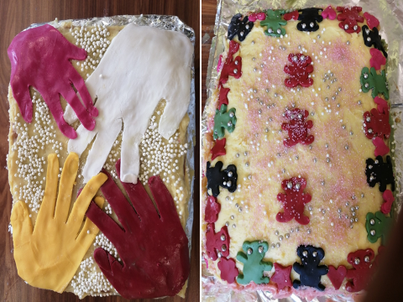
Food, death and taxes have been claimed by anthropologists as some of the factors that are common to all human beings. Food is considered an important marker of identity and cultural membership (Brulotte & Di Giovine 2014). In this public engagement activity, in collaboration with our community partner, the Broomhouse Centre, we employed cake making as a form of creative enquiry in order to elicit how a highly diverse group of kitchen trainees and staff constructed community, diversity and inclusivity. While decorating different shapes and colours of cakes, the participants were encouraged to engage in ‘phatic communion’ (Malinowski 1923, p. 315) not only to verbally elicit the themes but also to express their collaborative meaning-making through the embodied designing of their cakes. These cakes were then shared at a large community event, allowing the participants and researchers to discuss the themes and methodologies more widely.
This interactive session will reflect on the value of using visual methodologies when engaging with different publics, and invite participants to respond in kind.
References
Brulotte, R., & Di Giovane, M. (Eds.). (n.d.). Food and foodways as cultural heritage. In Edible identities: food as cultural heritage (pp. 1–38). Surrey: Ashgate.
Malinowski, B., Ogden, C. K., & Richards, I. A. (1923). The meaning of meaning. New York & London: Harcourt Brace Jovanovich.

Stream 2 Identity and work 2-3.15pm 2/09

Assessing the visual: participant generated photographs of family dinner (Professor David Marshall, Edinburgh University)

Purpose: we consider the potential for using participant generated photographs in family food research and ways to analyse this data.
Design/methodology/approach: research utilised participant generated photographs of midweek family dinners as part of a long interview photo elicitation exercise to provide visual data on domestic family dinners in eleven households.
Findings: participant directed photographs, or family selfies, are a way to involve all family members in the research. Allowing families control over the composition and production of the pictures offers an insight into how they enact and practice the family meal providing rich insights into the nature of this otherwise mundane consumption event. As well as acting as a prompt in long interviews the photographs provide a record of the event and capture contextual and spatial detail. This visual data allows for a thematic analysis within and across the study group to highlight variation in consumer practice drawing on descriptive, thematic, emotional and cultural contextual methods.
Originality/value: the findings contribute to the debate about the challenges in using visual methods and how the selfie technique can be employed, the photographs shared, and visual data incorporated as part of the research method. Moreover, it illustrates the potential to generate deeper insight into the social practice of eating together and the reveals often subtle cues as to what is happening around the domestic table. Photographs taken using a mobile phone, camera and selfie stick complement and stimulate traditional methods of qualitative investigation. As communicative affordances, these frame the practices around family dinner and afford the subject an agentic perspective as both producer and consumer of the image.
Key words: photographs, photo elicitation, selfie, selfie stick, communicative affordances, qualitative methods, visual data, family practice.

Online Fashion and Performative Cyber-Power of Social media Influencers (Fatma Bouarour, University of the West of Scotland)

Gender studies constitute a larger transition toward interdisciplinary research in academic domains (Woodward et al., 2014). This research is an essential piece of an interdisciplinary approach that provides both methodological and theoretical gains in analysing social worlds, as well as covering appealing topics such as women gaze, digital portrayal of women and online identity (Bahia, A., 2018). As previously stated, this research is interdisciplinary in nature. As a result, this provided an opportunity to approach the subject of gender from fashion and a sociological analytical standpoint using a contemporary research method. This topic of research is based on the performativity of Algerian women who have obtained online power through social media, rather than simply being a part of fashion trends. With the expansion of digital platforms such as Instagram, Facebook, YouTube and Tiktok, female influencers may have boosted the Algerian online identity and have provided more efficient ways to present and contest their gender online. So far, no large-scale research has been conducted to critically question online fashion and Algerian female influencers as a field of cyber power. Hence, the aim of the study is to critically interrogate online fashion and Algerian female social media influencers as a field of cyber-power where the contestation of cultural capital produces a gender performativity based on differentiation, distinction and dominance. Methodologically, the researcher is using netnography research approach, as well as online interviews, as a part of this method. Entering the investigation, interaction, and emersion phase, 11 Algerian female Instagram influencers who identified as women Algerian opinion leaders in the domain of fashion were recruited using purposive sampling. Furthermore, a digital diary is created in which the researcher observes and keep track of online gender performance. That is, how do those influencers express their identity through fashion? Are they displaying pure Algerian traditional fashion, a modest Muslim fashion identity, or are they influenced by postmodern fashion and using a fashion fusion of the traditional and the postmodern. This is accomplished by downloading the data, reading posts, selecting relevant data (deep data), and following hashtags to recruit more participants. As a result, a slew of hashtags have emerged, including #taryeltouch, #kabyletouch, #northafricaroot, and #root. This data will then be analysed using thematic analysis and an analytical framework (gender performativity and cultural capital theory).
Key words: Gender performativity, Cultural capital and Netnography

An exploratory study of how female entrepreneurs make sense of being a mother and business owner during an unexpected event: The case of the Covid-19 Pandemic (Professor Anna Watson, Dr Nika Balomenou, Dr Hannah Noke, Professor Brian Garrod)

This study explores how female entrepreneurs with children (for shorthand, mother entrepreneurs) make sense of competing demands of caring and running a business during times of crisis. In view of the long-standing gender entrepreneurship gap, and that policy responses to crises are typically undifferentiated in terms of gender, gaining a better understanding of the responses of women entrepreneurs, particularly mothers, is vital. Often having to juggle external obligations and identities, within the constraints of their responsibilities and roles, mother entrepreneurs have to make sense of being mothers and business owners in a rapidly changing reality. In the present study, 14 mother entrepreneurs participated in a volunteer-employed photography (VEP) exercise focusing on issues of identity, retrospective and ongoing sensemaking, and enactment. The use of VEP is relatively rare in social science research, despite its positive attributes that include reduced researcher bias and applying a visual lens to the experiences of participants. User-generated images can harness emotive power and, by embracing subjectivity, enable personalised, ‘verbatim’ experiential accounts to be captured. Participants were asked to document their experiences of balancing motherhood and entrepreneurship on camera. These data were analysed using a semiotic analysis and eight key themes were identified. These themes were validated and probed through interviews with the participants to explore further their sense-making. The findings reveal gendered responses to a crisis situation and how female entrepreneurs contend with their conflicting roles. (Please see accompanying visual below)
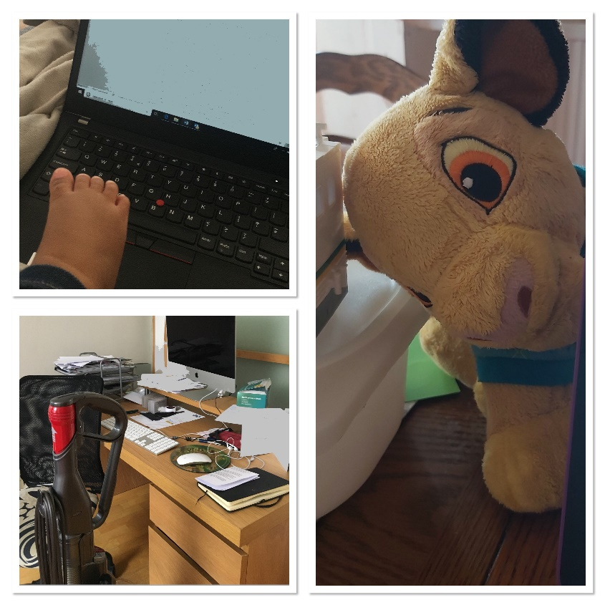

Poster Presentations

Labored Work of LGBTQ+ Influencers on Pride Branding (Raian Burgos Razal, Aarhuss University)

Brands often partner with LGBTQ+ influencers as part of Pride branding campaigns during Pride month. However, the current literature exploring LGBTQ+ influencers focuses on self branding (Abidin, 2019; Duguay, 2019), coming-out stories (Lovelock, 2017), or experimental studies that assess consumer-related outcomes (Li, 2021). Duguay (2019) presents us with the labor work of LGBTQ+ influencers in managing personal disclosures, aesthetics, and relational aspects. Yet it is still worth extending this labor from a branding point of view due to the active co-production of LGBTQ+ influencers with brands (Rundin & Colliander, 2021). The objective of this research is to identify the labored work conducted by LGBTQ+ influencers as they participate and collaborate in Pride branding. The methods will employ a netnographic and visual investigation of renowned influencers who have engaged and partnered with brands. The selection criteria involve having public Instagram accounts, being recognized as important influencers from media, and working with product and corporate brands for Pride (i.e. @chellaman, @blairirmani, etc.). This research will visually investigate and analyze their profile accounts on Instagram, communication of brand collaboration, and interview statements (Veresiu & Parmentier, 2021). The contribution lies in offering a more nuanced interpretation of the labored work of LGBTQ+ influencers in actively managing forces of authenticity tensions along dimensions of the self, the community, and the brand. Practically, it will inform the community on insights on collaborating with LGBTQ+ influencers.

Botched decisions? How Instagram influences the cosmetic surgery and non-surgical procedures consumption decisions of young women (Jasmiina Milne, Edinburgh Napier University)
This research explores the ways in which the use of Instagram influences Generation Z women to make cosmetic surgery and non-surgical procedure consumption decisions and analyses how their activities on Instagram impact upon their decision-making. The research adopts the consumer decision-making process (DMP) (Dewey, 2011; Engel et al., 1968) and takes a qualitative approach to bring new in-depth perspectives to the DMP research (Arab et al., 2019). The qualitative approach suits complex topics, including social media and cosmetic surgery contexts (Branthwaite & Patterson, 2011; Shauver & Chung, 2010). The methods chosen for data collection are netnography, a novel visual method social media user logs, and semi-structured interviews.
Netnography (Kozinets, 2020) is an essential component to understand how practitioners and influencers market cosmetic procedures on Instagram. After which, 30 Generation Z women are recruited to share their Instagram user logs and participate in semi-structured interviews. Social media user logs capture activities, behaviour and interactions on social media (Franz et al., 2019) and can enrich the data from the semi-structured interviews, which are ideal for collecting data on individuals’ perspectives, experiences and personal stories, particularly when sensitive, emotional and complex topics are being researched, such as cosmetic procedures (Shauver & Chung, 2010). Furthermore, interviews suit complex topics as they allow participants to express their own ideas and reflections (Askegaard et al., 2002). The research will contribute to the gap in the literature by understanding the complexity of the digital native females’ consumer decision-making in the much-needed area of everchanging social media marketing.

How do Saudi PhD(s) in the UK use Twitter? (Badryah Almesfer, Newcastle University)

In Saudi Arabia, Twitter has wide publicity, with 20.03 million users (Global media insight, 2020). Despite its importance socially, it remains an under-explored platform. This study examines the use of Twitter by Saudi postgraduate researchers in UK universities. The study addresses two questions:
1-How Twitter is being used by Saudi PhD students in the UK?
2-What can Twitter practices of Saudi (PhDs) reveal about them?
3-How and why are these practices being undertaken in such ways?
The study employs an online-ethnographic approach with participant observation for eight months from May 2019 until January 2020. The dataset of this study compromised screenshots of Tweets and interviews with the participants. The study is purely qualitative and after depth. Therefore, both datasets were analysed thematically, following Braun and Clarke (2006). To gain a better understanding of what these practices can reveal about this group. I observed Twitter as a participant (user) for eight months. I collected the tweets (screenshots) and conducted four interviews via Twitter Direct messages. The data includes Twitter profiles, Tweets, interviews, field notes, and journals.
This study found four main themes that these practices revolve around: PhDism, Muslim, Cosmopolitanism, and Saudi Arabianess. Previous studies, such as Han (2020), examined Chinese visiting scholars in the US and their Translanguaging practices on WeChat. However, this study adopts an online-ethnographic and grounded approach to provide an in-depth perspective of the idioms of Twitter practice enacted by this community.
References
Braun, V. and Clarke, V. (2006) 'Using thematic analysis in psychology', Qualitative Research in Psychology, 3(2), pp. 77-101.
Global media insight .2020 . Saudi Arabia Social Media Statistics 2020. [online] Available at: https://www.globalmediainsight.com/blog/saudi-arabia-social-media-statistics/ [ Accessed 21 Jun. 19].
Han, Y. (2020). Translanguaging as transnational spaces: Chinese visiting scholars’ language practices on WeChat. International journal of multilingualism, 17(2), 174-195.‏
Han, Y. (2020). Enacting identity and ethnicity in transnational spaces: bilingual practices and positioning of Chinese visiting scholars in America. Journal of Multilingual and Multicultural Development, 1-15.‏

The “cultural probe” and the art school, by Dan Bernstein, University of the Arts London

I work as an EAP (English for Academic Purposes) tutor, working predominantly with international students studying art & design subjects, supporting them in using English during their studies. I carried out a small-scale enquiry with Art & Design Foundation students, to gain some insight into how they view themselves and their English language use in relation to their practice, their studies, and the institution.
Amongst other qualitative research tools (focus group, semi-structured interviews) I used “cultural probes” (Gaver, Dunne & Pacenti, 1999) with a view to stimulating the students’ creativity and foregrounding their voice. “Probes” are exploratory research tools which encourage playful, creative responses to tasks and prompts, and are designed to produce a “richly textured but fragmented understanding” (Boehner, Gaver, & Boucher, 2012, p 185). The method was created by interaction designers with a view to overcoming barriers related to age, language and formal role between themselves and the communities they work with. I am very strongly struck by how these exact same barriers exist between myself and the students I work with, and also recognise that the creative aspect of this research tool is eminently applicable to the art & design education milieu.
This poster will include findings from the study and reflections on how both the technique of “probes” and the thinking behind them as exploratory, creative, and explicitly human can be applied to research in the field of language in art and design education.
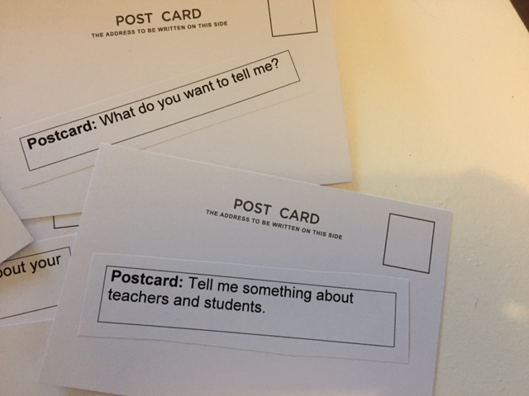
References:
Boehner, K., Gaver, W., & Boucher, A. (2012) ‘Probes’. In Lury, C. & Wakeford, N., Inventive Methods: The Happening of the Social. Abingdon, Oxon: Routledge, p 185-201
Gaver, W., Dunne, T., & Pacenti E. (1999). ‘Cultural Probes’. Interactions, (January/February), pp 21-29

How do Chinese gamers identify with each other in the game League of Legends?: An ethnographic study (Dan ZHAO University of Bath)

Playing multiplayer online games has played a unique role to provide opportunities to socialise among university students globally, particularly during the lockdown (Barr and Copeland-Stewart, 2021). The Chinese international students in the UK higher education are no exception. Yet, little attention has been paid to their behaviours within the games, especially the way they identify other Chinese players in EU servers when limited access to both verbal and written communication is given in games, namely League of Legends (LOL). LOL is a Multiplayer Online Battle Arena (MOBA) game that Riot Games designed and published in 2007 whereas now involves 180 million players (Stanton, 2021). Unlike other MOBA games such as DOTA2, the in-game communication option with stranger players in LOL is highly restricted due to the company’s policy. The Social identity model of deindividuation effects (SIDE model) suggests that anonymity alters the relative salience of personal and social identity (Vilanova et al., 2017). However, based on the initial in-game observation the Chinese gamers still manage to find a way to recognise each other successfully without having to contact and socialise with their peers outside the game, which brought out the main research questions of the current study: how do they do it? And does it have any impact on their social lives during the pandemic? Under the guideline of Grounded Theory, the researchers are proposing to conduct an ethnography study using in-game observations and interviews to explore further in order to provide an answer to the proposed questions.

Keywords: online-gaming, Chinese international students, pandemic

Reference:
Barr, M. and Copeland-Stewart, A., 2021. Playing Video Games During the COVID-19 Pandemic and Effects on Players’ Well-Being. Games and Culture [Online], 17(1), pp.122–139. Available from: https://doi.org/10.1177/15554120211017036 [Accessed 5 April 2022].
Stanton, R., 2021. With 180 million players, League of Legends games have more active users than Steam. PC Gamer. Available from: https://www.pcgamer.com/with-180-million-players-league-of-legends-games-have-more-active-users-than-steam/ [Accessed 6 April 2022].
Vilanova, F., Beria, F.M., Costa, Â.B. and Koller, S.H. (2017). Deindividuation: From Le Bon to the social identity model of deindividuation effects. Cogent Psychology, [online] 4(1). Available at: https://www.tandfonline.com/doi/full/10.1080/23311908.2017.1308104.

Picturing Java (Wo)man: Visual Reconstruction of Colonial Palaeoanthropology (Fiona Asokacitta University of Oxford,)

After Charles Darwin’s revolutionary Origin of Species (1859) and The Descent of Man (1871) were published, fossil discoveries became paramount in establishing the connection between humans and earlier life forms. However, despite decades of progress, the absence of the ‘missing link’ between apes and humans confounded scientists. In 1891 Dutch palaeoanthropologist Eugene Dubois unearthed what he claimed to be the missing link in the Dutch East Indies. He dubbed the fossil he discovered in Trinil, Java “Java Man” (Pithecanthropus erectus). Java Man was later found to be a subspecies of Homo erectus, but for a time debate raged regarding its place in human ancestry. Although Dubois’ discovery was limited to the skullcap, molar, and femur of Java Man, multiple artistic renderings of what the prehistoric hominid may have looked like populated textbooks, scientific journals, and museums. These purportedly scientific reconstructions of the missing link were extrapolated from scant empirical evidence. Nonetheless, images of Java Man played a crucial role in reifying the 'missing link' between modern humans and apes–both for scientific and lay communities. Through these images, Pithecanthropus’ position as ‘ape-man’ was widely accepted at the end of the nineteenth century. Reconstructions in the twentieth century and beyond familiarised popular audiences with the concept of human descent from apes. Drawing on Art History, Visual Anthropology, and History, this project analyses how visual reconstructions of Java Man generated between the end of the nineteenth century to the present were, and are, producers of knowledge within the intellectual history of evolution.

Thinking with my hands. Knitting as a way of analysing and connecting autoethnographic and ethnographic stories (Dr Javiera Sandoval Limarí UCL)

This presentation will explore the use of knitting, as art making, to analyse and to connect stories of my ethnographic fieldwork with autoethnographic data, to create new meaning for both. The Blanket is a crochet piece that I started to make after my mother’s death during my PhD. While knitting, I managed to understand and to connect my grieving self to the research I was doing, as the arts practice evokes emotions and foster reflection (Leavy, 2015). During the presentation I will explore on how knitting and weaving in crochet squares lead me to new understandings of the fieldwork I’ve done with Haitian children in a Chilean school. These new understandings, I propose, were a way of thinking with the hands, creating new connections, which were not visible to me while I was engaging in more traditional forms of data analysis. Within these connections, loss appears as a concept that created the interweaving between all the pieces. Myself in grief, the passing of my mother who lost her language due to Alzheimer’s disease and the loss of the mother tongue of Haitian children in Chilean schools. Engaging in arts, through the creation of The Blanket, was the media to reach the analytical categories that I am using to understand the experience of children in their process of losing their mother tongue and to find ways of resisting the loss of the mother tongue and the loss of the tongue of the mother. Leavy, P. (2015). Method Meets Art. Art-Based Research Practice (Second Edi). The Guilford Press.

